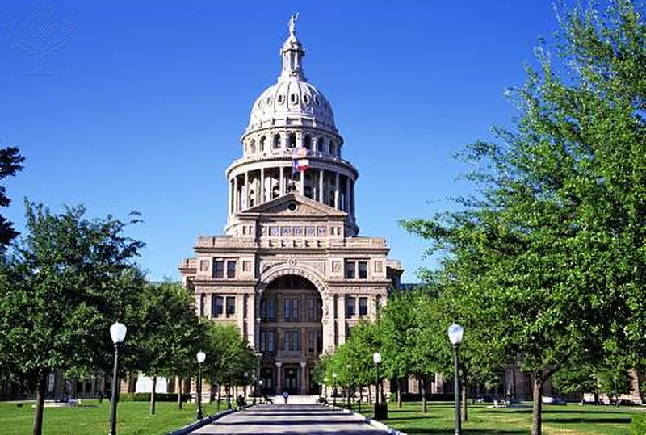
Texas State Capitol Building, Austin, Texas

Image Citations:
Sonora, California.. Photography. Encyclopædia Britannica ImageQuest. Web. 21 Sep 2015.
State Capitol Building in Austin, Texas. Photography. Encyclopædia Britannica ImageQuest. Web. 21 Sep 2015.

